BioFreshGuard – Ecological Freshness Intelligence Dashboard
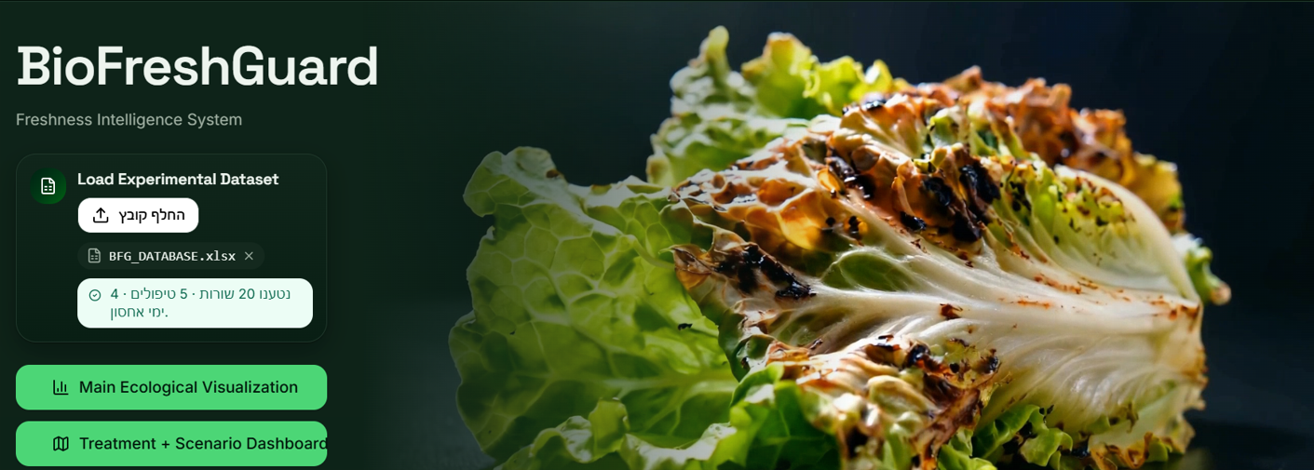
https://bio-fresh-guardpro.vercel.app

